***REPORT of MCB Bank:***

**FUNDAMENTAL OF MANAGEMENT**



**PROJECT:**

**MCB BANK**

**Group number 2**

***Report # 02***

**Group Members:**

• Ibrar Babar (19P-0104)

• Asjid Tahir (p19-0085)

• Usman Manzoor (p19-0068)

• Umar Farooq (p19-0065)

**PEST Analysis of MCB**

The analysis of MCB will take in to account the general environment analysis, the competitor’s analysis by comparing the products offered by the competitive banks and the departmental analysis.

The general environment of takes in to account the external factors like politics, economy of Pakistan, socio-cultural factors and technology. Now we will analyze these factors one by one and check how these affect the working of MCB:

**Political**

The current situation of the government in Pakistan is directly affecting the policies of banks. However, MCB tries hard to keep its business away from the politics but it is not an easy task. MCB has no accounts of political leaders or parties. However, its Customer Service Department faces peer pressure from such political parties.

As MCB is trapped in dual sanctions from the State Bank of Pakistan (SBP) and from the European Union so the changing political environment is not so beneficial for the bank to operate freely. The changing policies of the government, affects SBP which in return affects the MCB rules and policies.

The government of Pakistan has privatized most of the banks. The number of government owned banks have declined constantly, so these changes directly affect MCB.

**Economical**

The economy of any country has deep impact on any financial organization. Economic indicators include Gross Domestic Product (GDP), inflation, balance of payment, debt of the government. These below graphs will explain how economic conditions of Pakistan are adversely affecting the banking system of Pakistan.

The pitiable economy of Pakistan and instable government is adversely affecting MCB and its different departments; recently MCB has redundant many of its employees. The economy of our Pakistan is very poor. Due to poor economy businesses are showing low profits and Pakistan stock market is in great danger. Pakistan’s foreign debts are rising day by day, so such a situation is a huge challenge for MCB to survive. Due to financial crisis in Pakistan the management of MCB has to face stressful situations and also working environment. At present the MCB is not extending loans but recovering the existing ones.

**Social**

MCB has been influenced by the socio-cultural factors. At present most of the European countries are keeping their eyes on Pakistan as being the terrorist country, so people of Pakistan are emotionally getting affected by it. Most of the foreign investments have been stopped in Pakistan. Pakistani people are traditionalists who do not like the modern banking environment of MCB. Some of the customers do not use ATMs they still prefer cash counters, so these kinds of socio-cultural factors affect the banking environment and its operations.

**Technological**

Technology has a deep influence on different kinds of organizations whether banks or any kind social welfare organizations. In MCB technology has great effect on the working environment. Mostly all banks use computers none of the banks keep data manually so the bank has to be continuously in touch with the modern ways of task performance. MCB is always ahead to introduce new computer systems for keeping its staff up to date. The intranet facility is playing an important role in enhancing the knowledge of staff. Due to technology that bank staff keeps in touch with the customers through e – mail; ATMs and online banking is only possible due to technology. In this way technology is playing its key role in and is helping management to further improve its functions.

**Shareholding Pattern:**

This is the shareholding Report of 2019

As of Dec 31, 2019

|  |  |  |  |  |
| --- | --- | --- | --- | --- |
| **Description** | |  |  | | --- | --- | | **Shares held** |  | | **Percentage** |
| |  |  | | --- | --- | | Directors, Chief Executive Officer, and  their Spouses and Minor Children |  | | |  |  | | --- | --- | | 119,605,330 |  | | |  | | --- | | 10.0928% | |  | |
| |  |  | | --- | --- | | Associated Companies,  Undertakings and Related Parties |  | | 215,730,246 | |  | | --- | | 18.2042% | |  | |
| |  |  | | --- | --- | | NIT & ICP |  | | 912 | |  | | --- | | 0.0001% | |  | |
| |  |  | | --- | --- | |  |  | | Banks, Development Financial Institutions,  Non-Banking Financial Institutions |  | | |  |  | | --- | --- | | 16,218,227 |  | | |  | | --- | | 1.3686% | |  |  |  | | --- | |  | |  | |
| |  |  | | --- | --- | | Insurance Companies |  | | 100,220,314 | |  | | --- | | 8.4570% | |  | |
| Mod arabas and Mutual Funds | 7,455,211 | |  | | --- | | 0.6291% | |  | |
| |  |  | | --- | --- | | Shareholders Holding 10% |  | | General Public (Local) |  | | 222,606,147  134,139,330 | |  | | --- | | 18.7844% | |  | | 11.3192% | |  | |
| |  |  | | --- | --- | | General Public (Foreign) |  | | 3,132,548 | |  | | --- | | 0.2643% | |  | |
| |  |  | | --- | --- | | Others |  | | 365,951,741 | |  | | --- | | 30.8804% | |  | |
| **Total** | **1,185,060,006** | **100.0000%** |

**Corporate Sustainability Report (CSR):**

As one of the largest Banks in Pakistan, MCB Bank, has a great legacy of service and innovation spanning over 72 years. The Bank always strives to adopt best practices and cultivating a culture of discipline and values which preserve the interests of all relevant stakeholders.

Through the promotion and deployment of projects and services that work in a socially responsible way, MCB Bank stresses upon the importance of environmental sustainability and the social well-being of its employees and society as a whole.

**Our policy**

MCB Bank undertakes CSR initiatives with a vision to contribute towards harmonious and sustainable development of communities. Following will be the framework and broad parameters for CSR activities by the Bank to:

**1**. Comply with applicable laws and regulations as well as the spirit thereof and conducts business operations with honesty and integrity.

**2**. Promote and engage in social welfare activities that help strengthen communities and contribute towards the uplift of society.

**3**. Support and promote Financial Inclusion.

**4**. Endeavor to build and maintain sound relationships with customers and other stakeholders through open and fair communication in order to contribute towards sustainable image building.

**5**. Honor the culture, customs, history and laws as the Bank constantly searches for safer, cleaner and superior practices that satisfy the evolving needs of the society.

**6**. Strive to develop, establish and promote practices enabling the environment and economy to coexist harmoniously whilst encouraging minimum wastage of resources.

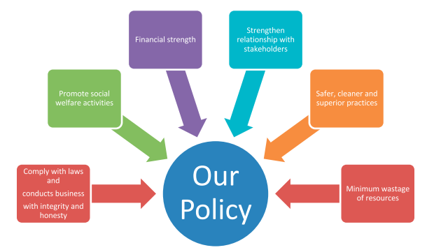

**Our approach to sustainability**

The Bank has focused on several key principles as an institution. It is committed towards fostering a better work place and cleaner environment through its varied initiatives. By committing to a culture of excellence, good governance, transparency and integrity, it ensures that all activities are conducted in a manner that is ethically responsible and beneficial for all stakeholders. MCB Bank has a well-defined Code of Ethics and Conduct policy that serves as a guideline for the behavior and ethics of employees.

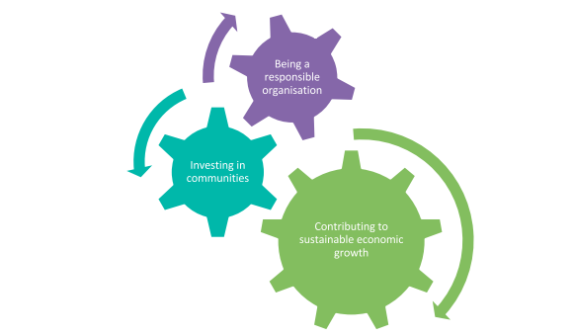

**Contributing to sustainable economic growth:**

MCB Bank uses its core business of banking to promote sustainable development in all the markets it operates.

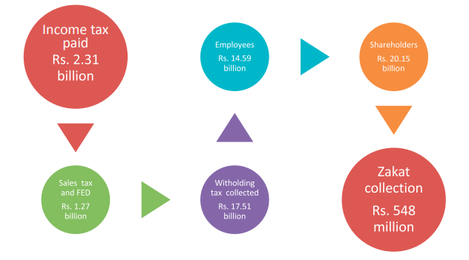

**Ethical Values:**

Introduction: MCB Bank’s Vision is to be the leading financial services provider, partnering with customers for a more prosperous and secure future. To achieve this vision, the Board of Directors sets strategic aims of the Bank and provides entrepreneurial leadership within a framework of prudent and effective controls which enables risk to be assessed and managed. The Board formulates values and the highest standards of integrity to ensure that Bank’s obligations to its customers, shareholders and other stakeholders are understood and met. The directors perform their fiduciary duties in a way where conflict between their personal interests and their duty as fiduciaries is avoided. MCB Bank has earned a reputation built on honesty and fairness of its directors and employees.

The Directors are entrusted with and are responsible for overseeing the conduct and management of business affairs of the Bank by the Management, in an honest, fair, diligent and ethical manner. The principles in the Code provide for individual and collective responsibility of all directors and require a consistent and high standard of ethical conduct by all directors.

1. **Compliance with Laws and Regulations:**

MCB Bank operations are subject to numerous laws and regulations in jurisdictions in which it carries on its business, which have an impact on its products and services. Violation of any law can affect MCB Bank’s reputation and its ability to carry on its business effectively. Directors, who are required to oversee the affairs of the Bank, shall assure that the management is carrying out its affairs prudently in line with existing laws, rules and regulations.

1. **Ethical Conduct:**

The financial services industry in which MCB Bank operates is built on the highest levels of trust. Integrity is a cornerstone of the business. Directors shall act on behalf of the Bank with professionalism, honesty and integrity as well as high moral and ethical standards.

1. **Disclosure of Interest:**

Directors must take care to ensure that they identify and avoid any situation of actual or apparent conflict of interest, whether the situation involves the director directly or a member of his or her immediate family. Every director, including his/her spouse and minor children, who is in any way, whether directly or indirectly, concerned with or interested in any contract or arrangement entered into, or to be entered into, by or by the Bank shall disclose the nature of his/her concern or interest at a meeting of the directors and abstain from discussion, voting or otherwise influencing a decision on any matter related to such contract and/or arrangement.

1. **False or Misleading Statements:**

Directors shall not make a statement or disseminate information, which is misleading or false and/or is likely to induce sale or purchase of securities by any person and/or is likely to affect the market price of the Bank’s shares.

1. **Protecting or dealing in Bank’s Assets and Services:**

Directors shall oversee the Management’s control on the Bank’s physical assets and shall ensure that management invests in assets that are required for the purpose of conducting Bank’s business. Directors shall monitor implementation of such policies to ensure that the assets of the Bank are protected from being misused. Further, directors shall not enter into leasing, renting and sale/purchase of any kind with the Bank.

However, this restriction shall not apply in case of purchase by paid directors (executive directors) of vehicles, laptops, mobile phone devices and iPads which remained in their own use, provided such sale is covered under the employees service rules duly approved by the Board and is effected at least at book value at the date of such transaction.

**9. Anti-Competitive Practices:**

Competition fosters a fair and effective financial services industry. Accordingly, directors are expected to comply with competition legislation and may not, on behalf of the Bank, agree with other financial Bank for Life Code of Conduct & Ethical Standards Page 5 of 6 institutions or businesses to (I) fix interest rates, prices, charges or types of services or (ii) avoid competing for customers in particular product categories or geographic markets

**11. Evaluation of the Board:**

The performance of the Board as a collective body shall be evaluated as per mechanism prescribed by the Board.

**12. Priority to Bank’s Interests:**

Directors shall be required to ensure that the Bank’s interests take priority over all other interests.

***Conclusion:***

**Overall we can say that MCB is influenced by the economic position of Pakistan, which has stopped it from extending loans to the customers. After that the policies of MCB are also affecting its performance and free functioning. Social and technological issues are of secondary importance but they also cannot be neglected. MCB is focusing positively regarding technological issues but it should also keep its eye on the social cultural factors also.**

**Financial Goals:**

**Vision:**

To be the leading financial services provider, partering with our customers for an ore prosperous and secure future.

**Mission statement:**

We are the team of committed professionals, providing, innovative and efficient financial solutions to create and nature long-term relationships with our customers.in doing so, we ensure that our shareholders can invest with confidence in us.

***Strategic Goals of MCB Bank***

***Core Values***

* **Integrity**. We are the trustees of public funds and serve our community with **integrity**. ...
* Innovation. We encourage and reward people who challenge the status quo and think beyond the boundaries of the conventional. ...
* Excellence. ...
* Customer Centricity. ...
* Respect.